PRDA – 03 HR Analytics
Name: APEKSHA BAWANKAR
---------------------------------------------------------------------------------------

Executive Summary
HR Analytics can provide valuable insights and benefits to organizations in many different areas, from talent acquisition and retention to workforce planning and diversity and inclusion. By leveraging HR Analytics, companies can gain a competitive advantage by developing data-driven strategies that help them attract and retain top talent, improve employee engagement and performance, and foster a positive and inclusive workplace culture.
This particular dataset holds 13 columns and 22,214 records. The 13 columns has information like their name, birth date, race, what department they work at, their job title, remote/HQ, hire date, term date, city and state.

First we understand the data fully by performing various queries.

1. Get data from the database with the given credentials.
For the database, I am using MySQL Workbench;
I have connected the database with the given credentials and started analyzing it.

Now, check what kind of data we have

checking number of records in the table HR
select count(*) from HR;
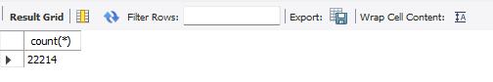
There are 22214 numbers of records in total.

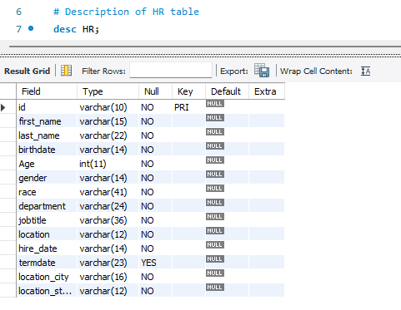

Handling Missing or Null Values
Before we find missing or nulls lets arrange data in rows by removing extra spaces.
#Viewing some rows entry

select * from HR LIMIT 10;
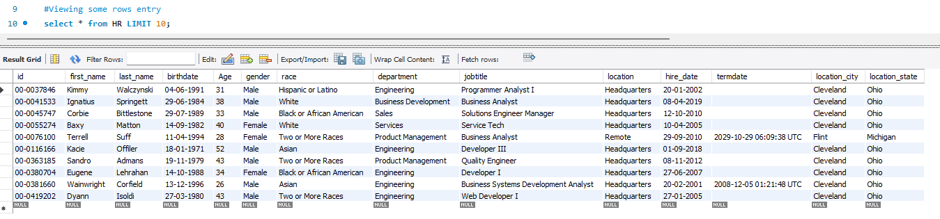
Data seems to be perfectly entered without and extra spaces.

#Finding Null Values
select count(*) from HR where department IS NULL;
select count(*) from HR where jobtitle IS NULL;
select count(*) from HR where age IS NULL;
select count(*) from HR where HIRE_DATE IS NULL;
select count(*) from HR where termdate IS NULL;
select count(*) from HR where location IS NULL;

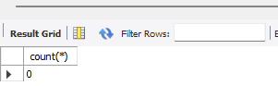
Results show there are no null values in the table.

Removing Duplicate Records
Duplicates can skew your analysis. You can identify and remove them using Common Table Expressions 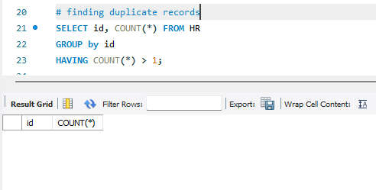

There are no duplicate records.

Handling Outliers and Invalid Data
Filter out or correct values that fall outside logical ranges (e.g., negative ages).
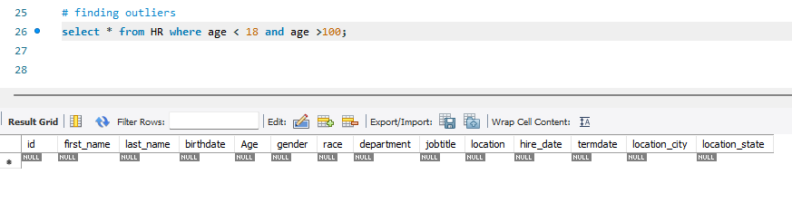
There are no outliers.

Number of employees
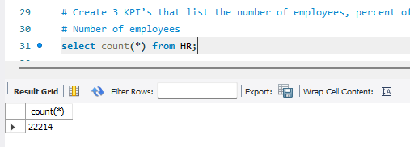
percent of workers working remotely and in HQ and the average age.
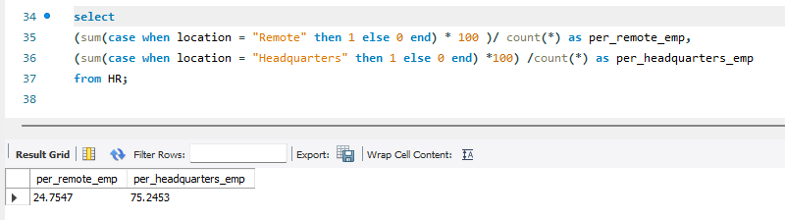
Percentage of remotely working employees = 24.7547
And Percentage of employees who work in headquarters = 75.7253

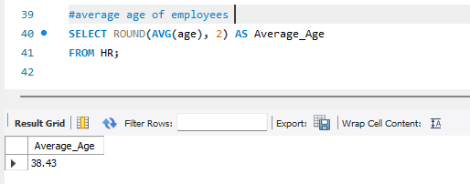
The average age of employees is 38.43.

2. Retention & Attrition Analysis
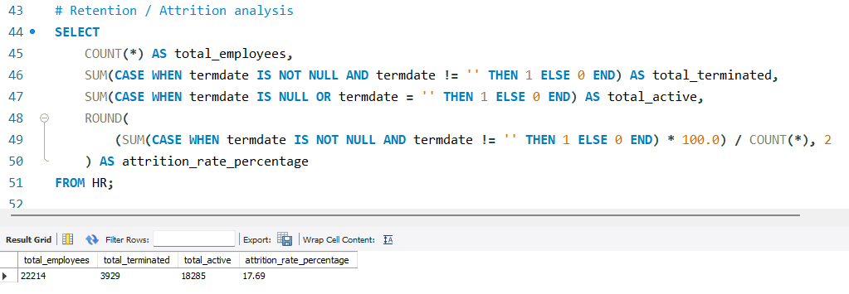
Attrition rate by departments
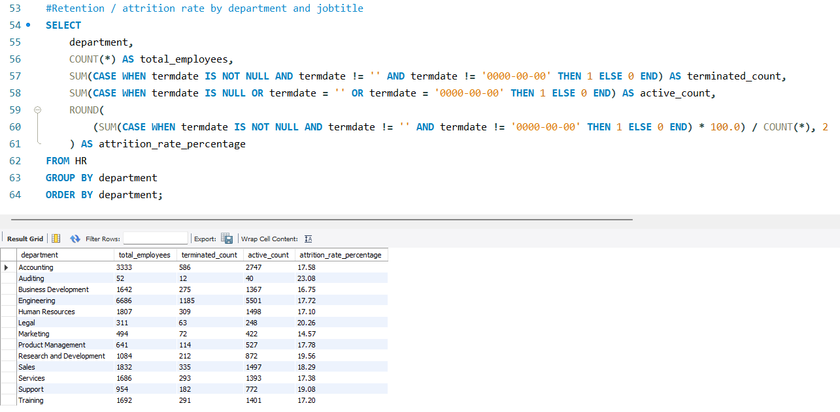

3. Demographic & Diversity Metrics : Gender & Diversity Breakdown: Ratio of male, female, and non-confirming employees across departments.
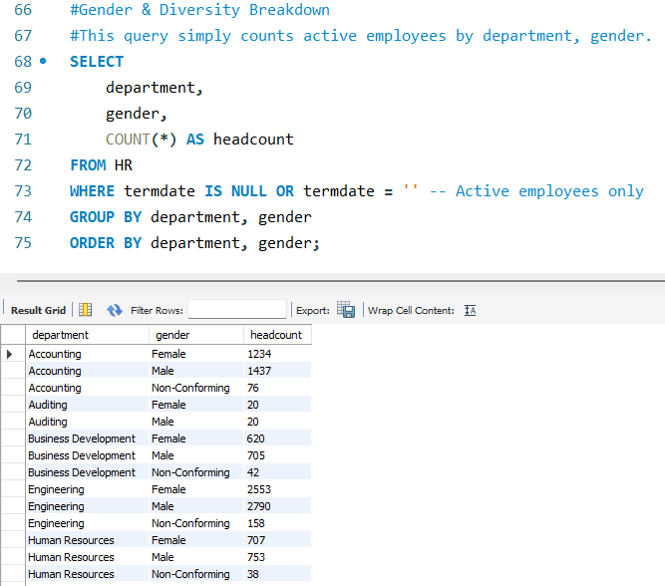

4. Geographic & Location Analysis : State / City Distribution: Distribution of workforce across specific cities and states.
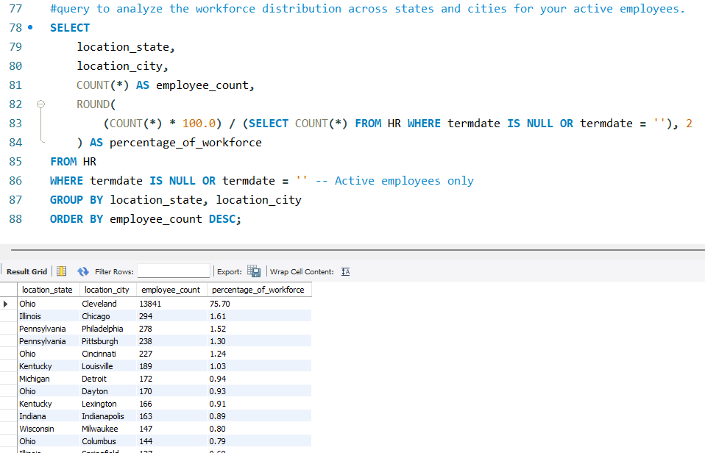

5. Career Growth & Department Dynamics : Department/Job Title Count: Total count and percentage of employees per department and job title.
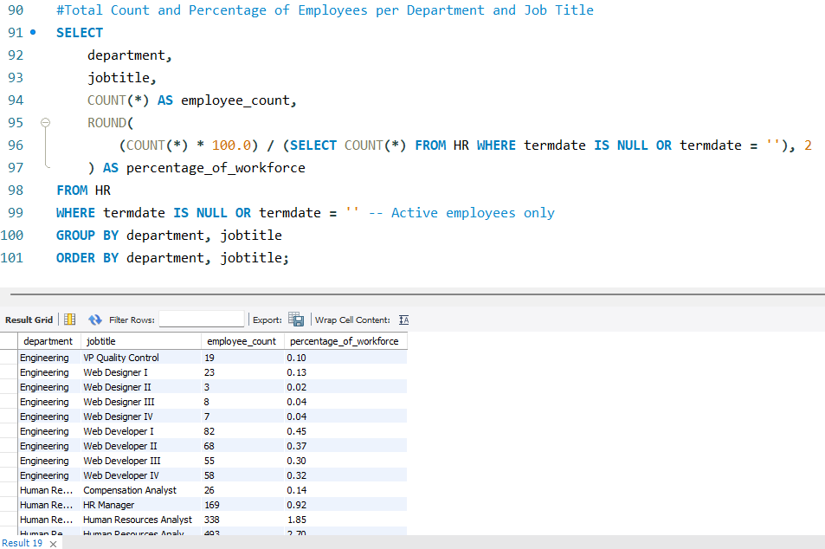
Tenure / Length of Service: Average tenure of active employees
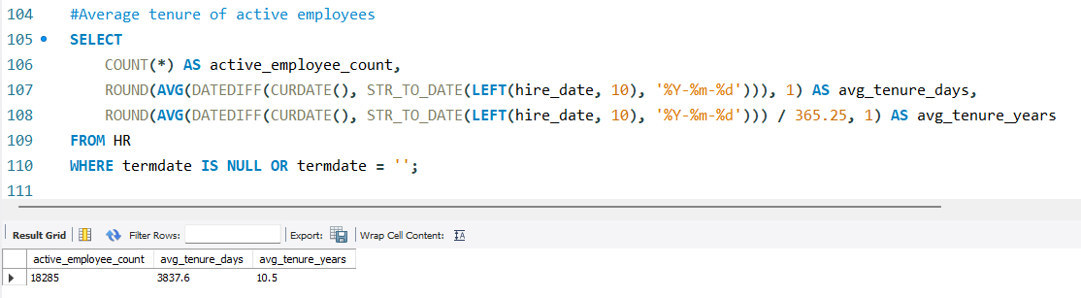

6. Key Business Insights & Recommendations

Based on the comprehensive data analysis of the 22,214 employee records—spanning demographics, geographic distribution, tenure, and attrition—the following actionable insights and strategic recommendations are proposed for organizational growth and workforce optimization:

HQ-Centric Workforce with a Remote Footprint: With roughly 75.7% of employees working in Headquarters and 24.7% working remotely, the organization maintains a strong physical office culture while offering flexibility to a quarter of its staff.
A Career-Prime Workforce: The average employee age of 38.43 years indicates a young-to-middle-aged, highly energetic workforce. This demographic is typically focused on professional growth, work-life balance, and long-term career progression.
Departmental & Geographic Concentration: Analyzing headcounts across departments, job titles, states, and cities highlights distinct operational hubs and potential talent clusters.
Attrition & Tenure Dynamics: Tracking length of service alongside department-specific turnover provides visibility into critical retention windows and helps identify departments vulnerable to higher exit rates.

Strategic Recommendations

1. Optimize Flexibility and Remote Work Policies
- Recommendation: Since nearly a quarter of the workforce is remote, ensure equitable access to tools, communication channels, and cultural engagement initiatives.
- Impact: Maintaining strong connection and collaboration between HQ and remote employees prevents silos and preserves company culture.

2. Enhance Career Development and Upskilling Programs
- Recommendation: Given the average age of ~38, design structured career progression pathways, leadership training, and mentorship programs.
- Impact: Providing clear upward mobility helps satisfy career-driven employees, directly reducing voluntary turnover and retaining top internal talent.

3. Targeted Retention Strategies by Department and Tenure
- Recommendation: Use departmental attrition and tenure metrics to pinpoint high-turnover areas. Focus retention interventions (such as pulse surveys, compensation reviews, or manager check-ins) on departments or tenure milestones experiencing the highest loss rates.
- Impact: Proactive interventions save recruitment costs and protect institutional knowledge.

4. Drive Regional Diversity and Inclusion (D&I) Initiatives
- Recommendation: Leverage the state/city distribution and gender/diversity breakdown data to ensure inclusive hiring and talent pipelines across all geographic hubs and leadership tiers.
- Impact: Fosters a balanced, equitable workplace culture that attracts diverse talent globally and locally.

_______________end of file__________________

